Vision Document for “RentaCar”

Team members:

Tegshbayar Ganbat

1. Introduction
The Rental Car Management System is designed to simplify and automate the vehicle rental process for customers and rental companies. It enables customers to search, reserve, rent, and return vehicles, while allowing administrators to efficiently manage vehicle inventory, reservations, payments, and maintenance. The system improves operational efficiency, prevents booking conflicts, and enhances the overall customer experience through a scalable and object-oriented software design.
2. Positioning

2.1 Problem Statement
[Provide a statement summarizing the problem being solved by this project. The following format may be
used:]

The problem of | Check car availability and provide car
Affects | administrators, customer
the impact of which is | reservation is complex, must be manually maintained, and changed frequently
a successful solution would be | one tool which builds a rental car reservation that integrates the  business rules for car availability needed by  customer. This tool will provide a Database and a  user interface that is easy to use for admin, staff, and  customers.

2.2 Product Position Statement
[Provide an overall statement summarizing, at the highest level, the unique position the product intends to
fill in the marketplace. The following format may be used:]

For | [target customer]
Who | [statement of the need or opportunity]
The (product name) | is a [product category]
That | [statement of key benefit; that is, the compelling reason to buy]
Unlike | [primary competitive alternative]
Our product | [statement of primary differentiation]

[A product position statement communicates the intent of the application and the importance of the project
to all concerned personnel.]
3. Stakeholder Descriptions

3.1 Stakeholder Summary

Admin – add/remove cars
Staff – confirm car reservations and assign car to customer
Customer – make a reservations and change/cancel reservation

3.2 User Environment

[Detail the working environment of the target user. Here are some suggestions:
Number of people involved in completing the task? Is this changing?
How long is a task cycle? Amount of time spent in each activity? Is this changing?
Any unique environmental constraints: mobile, outdoors, in-flight, and so on?
Which system platforms are in use today? Future platforms?
What other applications are in use? Does your application need to integrate with them?
This is where extracts from the Business Model could be included to outline the task and roles involved,
and so on.]

4. Product Overview

4.1 Product Perspective
[This subsection of the Vision document puts the product in perspective to other related products and the
user’s environment. If the product is independent and totally self-contained, state it here. If the product is a
component of a larger system, then this subsection needs to relate how these systems interact and needs to
identify the relevant interfaces between the systems. One easy way to display the major components of the
larger system, interconnections, and external interfaces is with a block diagram.]

4.2 Assumptions and Dependencies
[List each factor that affects the features stated in the Vision document. List assumptions that, if changed,
will alter the Vision document. For example, an assumption may state that a specific operating system will
be available for the hardware designated for the software product. If the operating system is not available,
the Vision document will need to change.]

4.3 Needs and Features

[Avoid design. Keep feature descriptions at a general level. Focus on capabilities needed and why (not
how) they should be implemented.]

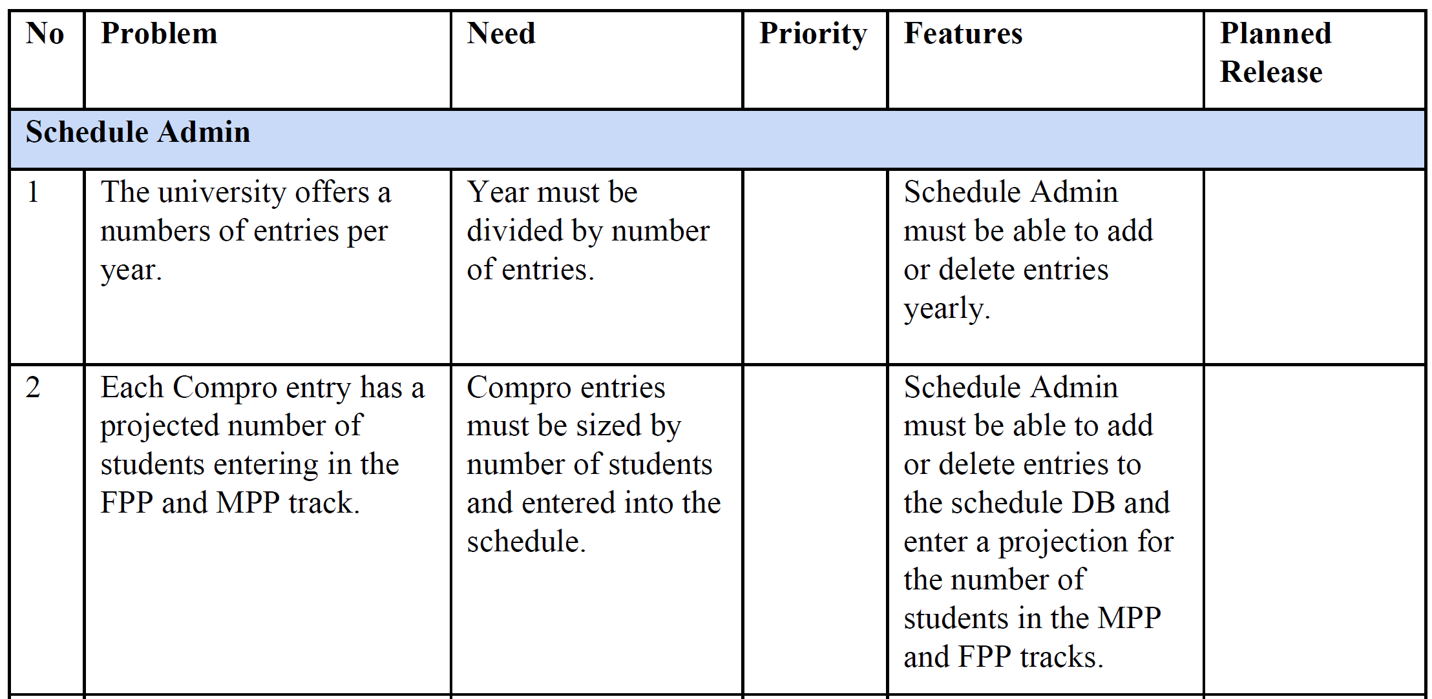
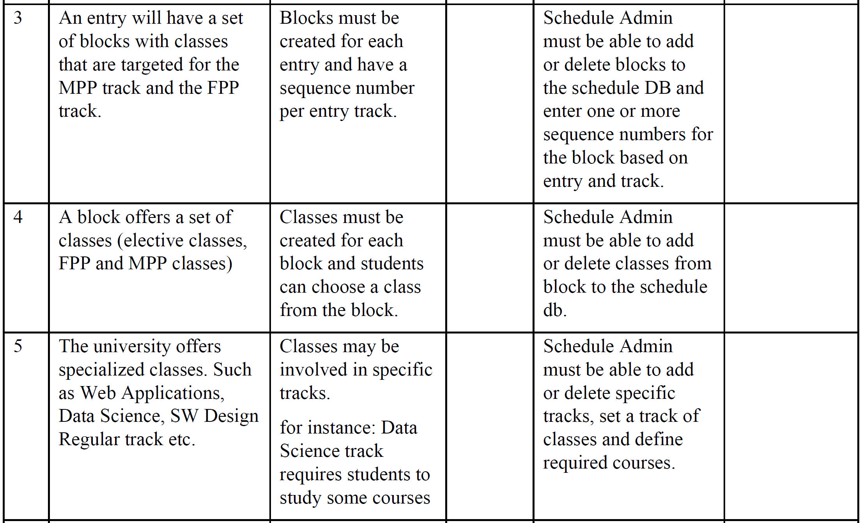
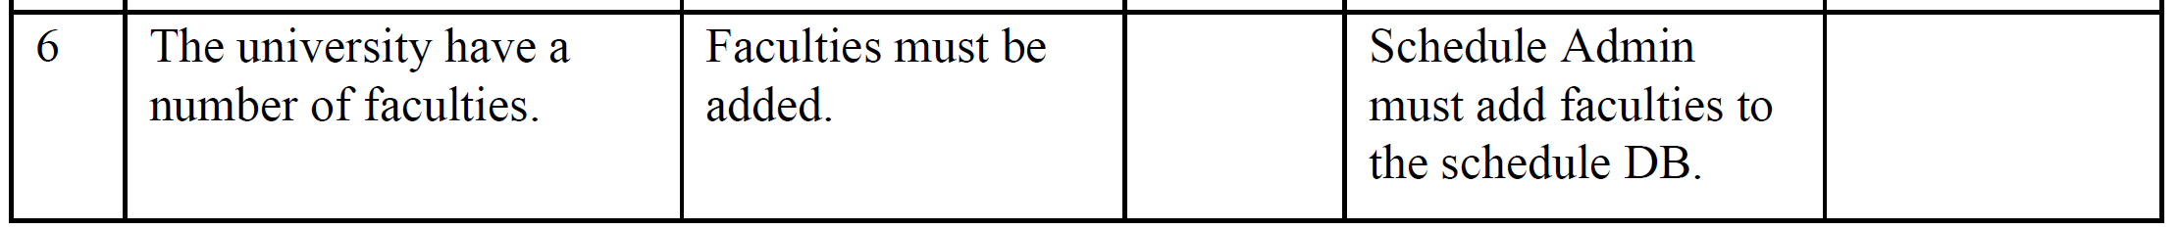
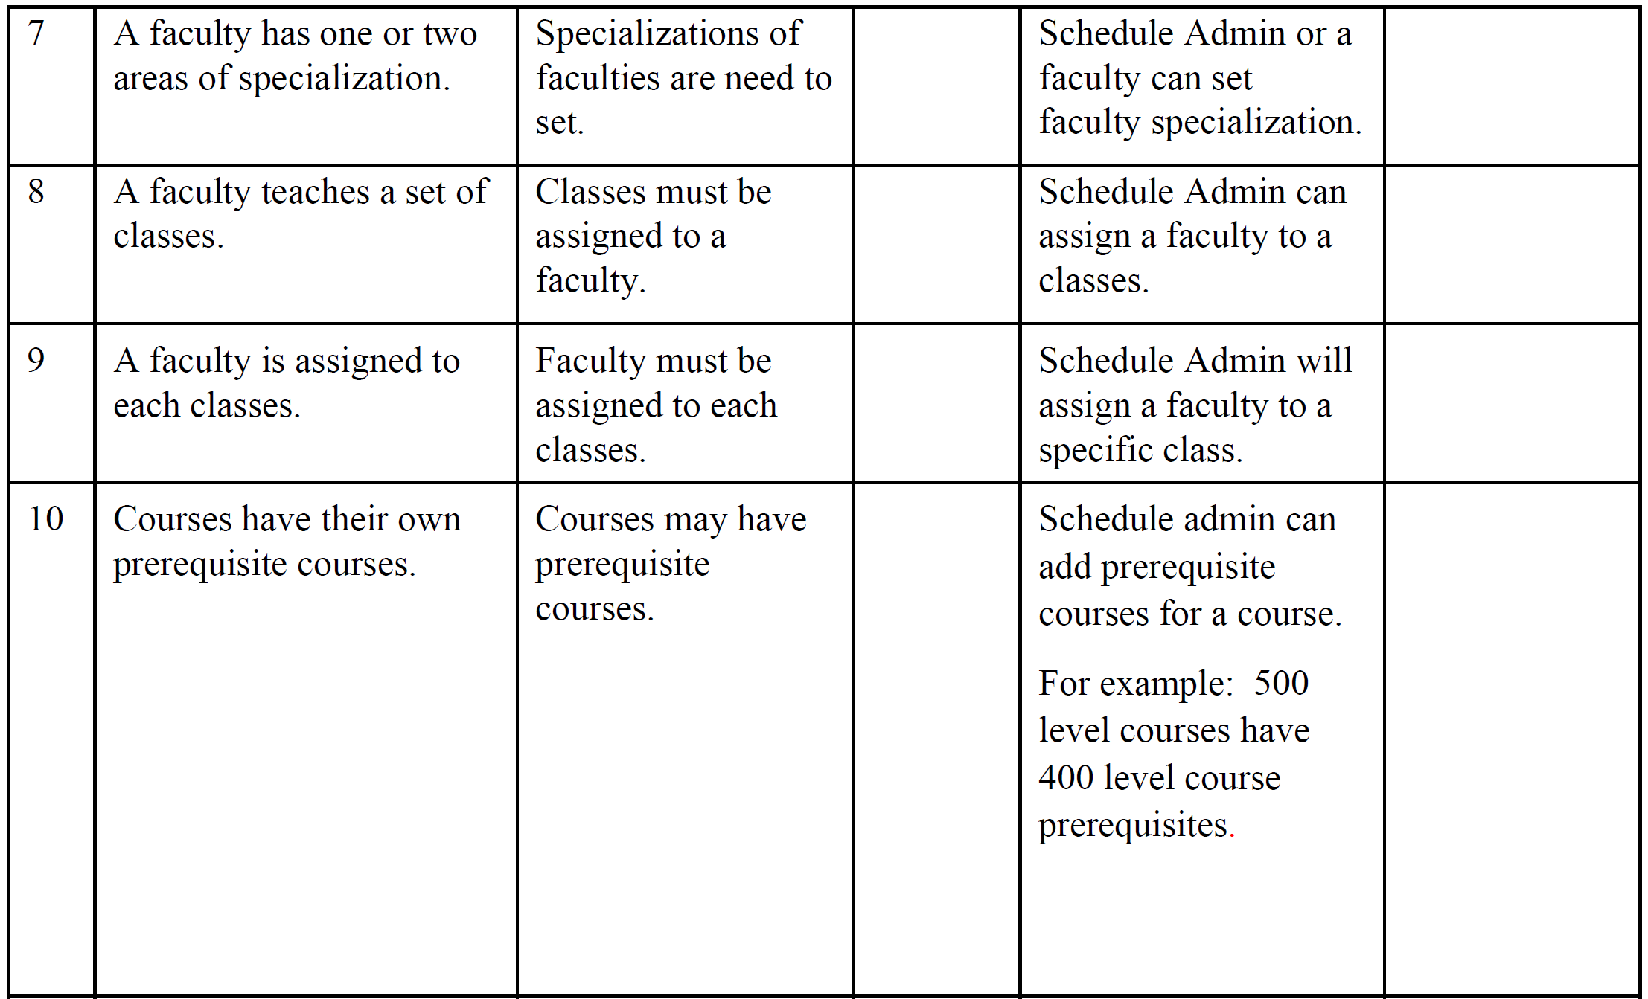
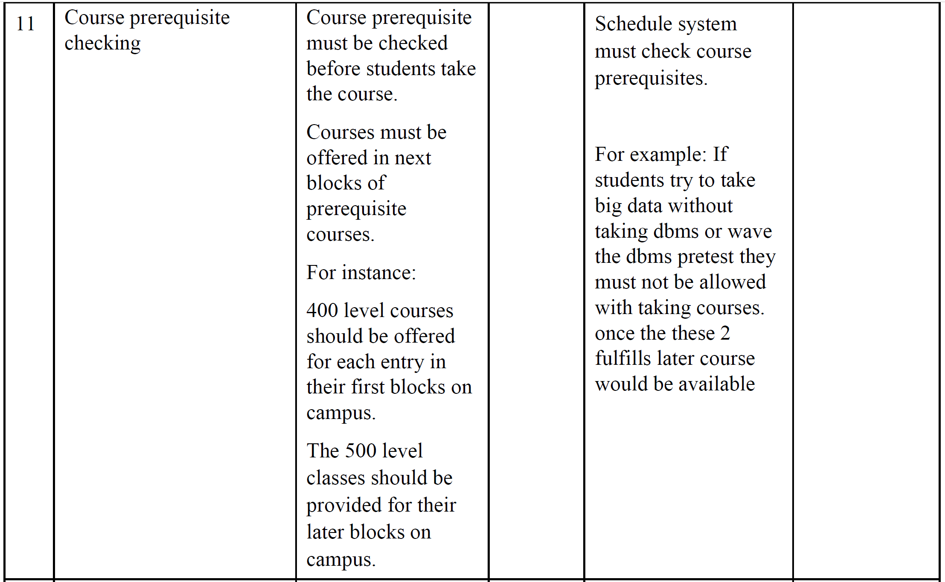
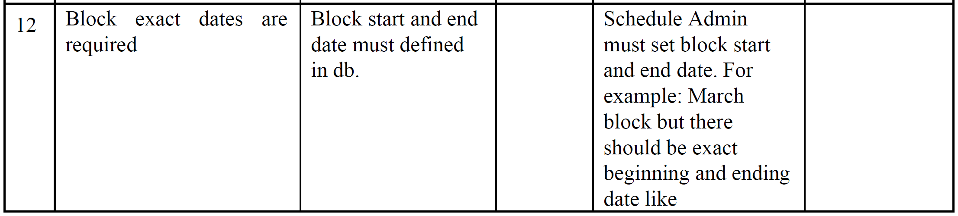
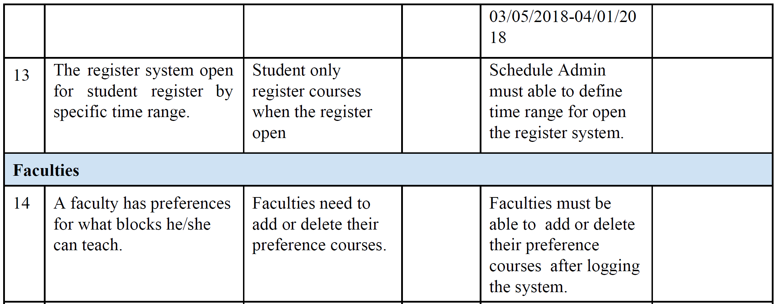
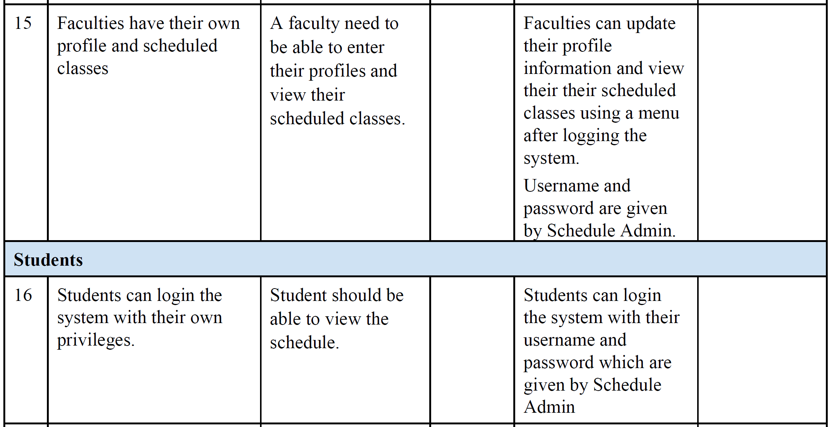
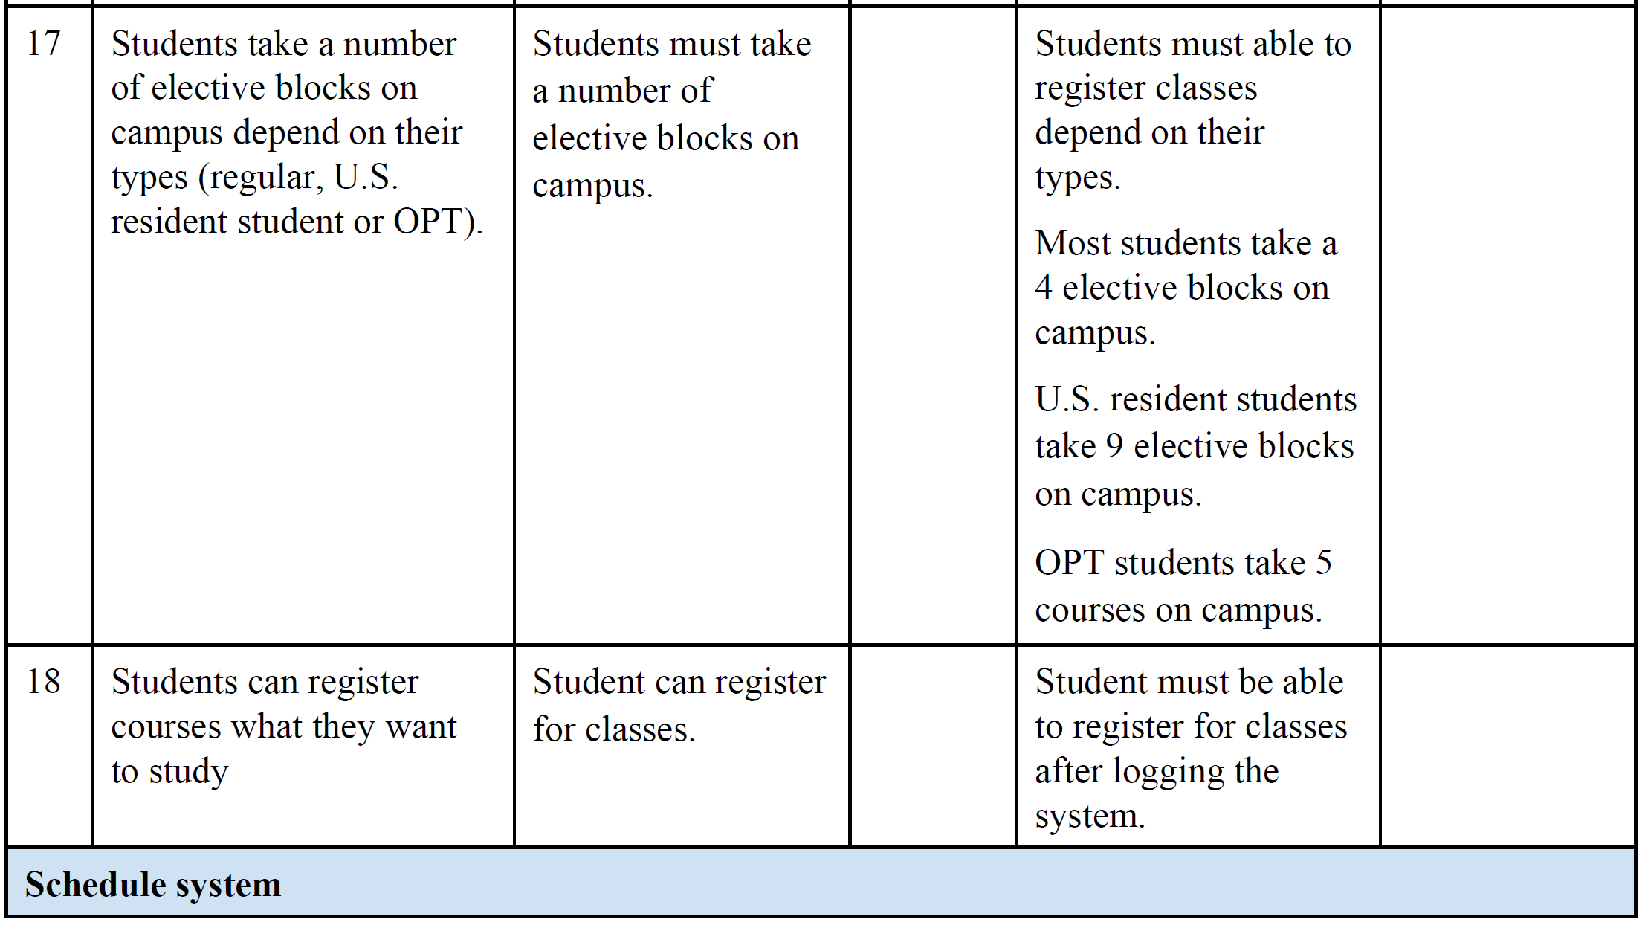
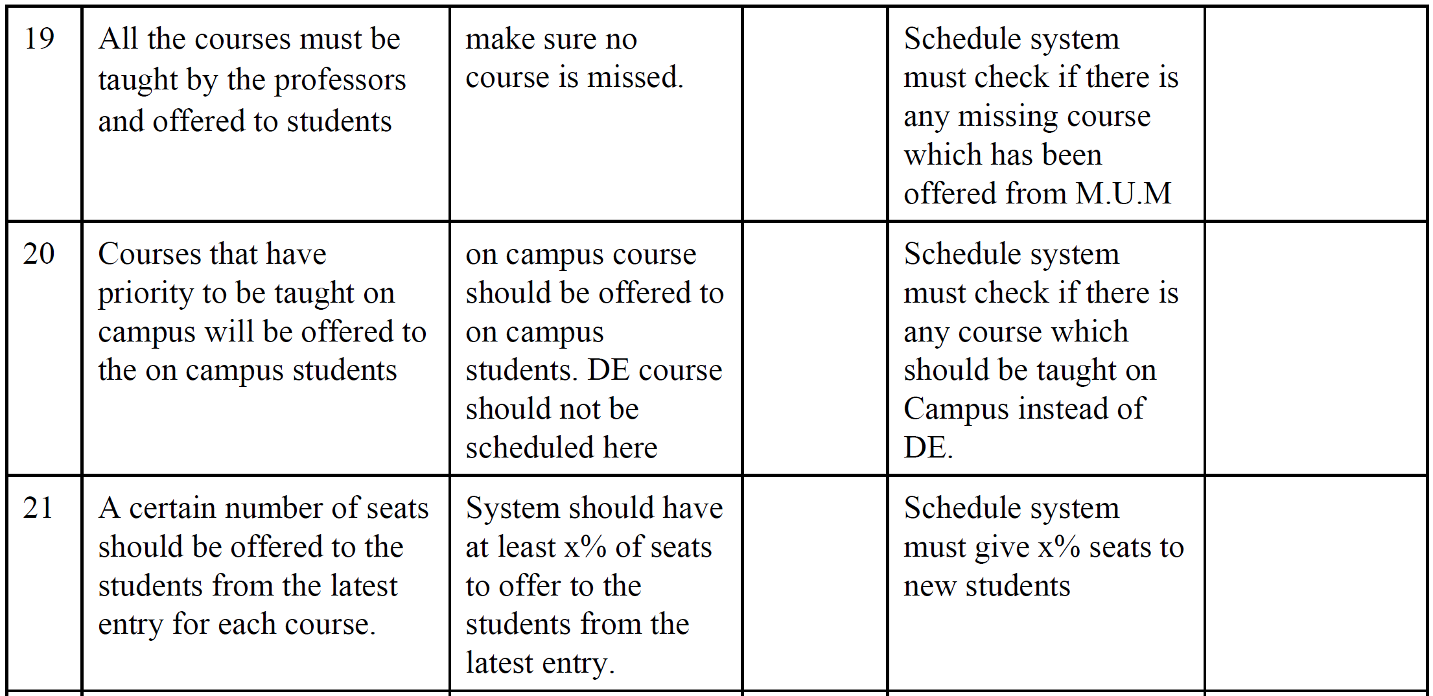
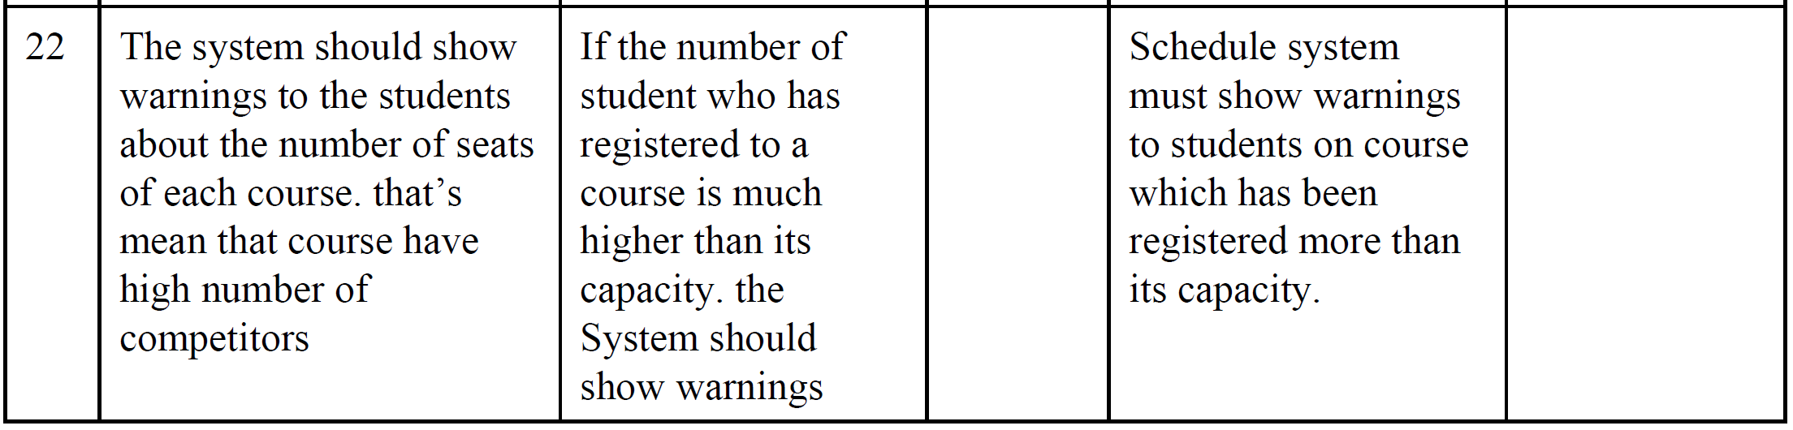

4.4 Alternatives and Competition
[Identify alternatives the stakeholder perceives as available. These can include buying a competitor’s
product, building a homegrown solution, or simply maintaining the status quo. List any known competitive
choices that exist or may become available. Include the major strengths and weaknesses of each competitor
as perceived by the stakeholder or end user.]

5. Other Product Requirements

[At a high level, list applicable standards, hardware, or platform requirements; performance requirements;
and environmental requirements.
Define the quality ranges for performance, robustness, fault tolerance, usability, and similar
characteristics that are not captured in the Feature Set.
Note any design constraints, external constraints, or other dependencies.
Define any specific documentation requirements, including user manuals, online help, installation,
labeling, and packaging requirements.
Define the priority of these other product requirements. Include, if useful, attributes such as stability,
benefit, effort, and risk.]

